NAME: VENKATRAMAMOORTHY.G
- What is JavaScript? Write a simple script.
JavaScript is a programming language used to make web pages interactive. It runs in the browser.
- Update content dynamically
- Handle user actions (clicks, typing, etc.)
- Change styles and animations
CODE:
console.log("Hello, JavaScript!");
OUTPUT:
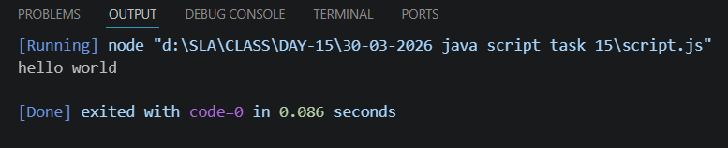
- Add a script tag inside HTML and print 'Hello JS'.
CODE:
<!DOCTYPE html>
<html lang="en">
<head>
<meta charset="UTF-8">
<meta name="viewport" content="width=device-width, initial-scale=1.0">
<title>java script</title>
</head>
<body>
<h1 id="h1"></h1>
<script>
console.log("hello js");
document.getElementById('h1').innerHTML="Hello js";
</script>
</body>
</html>
OUTPUT:
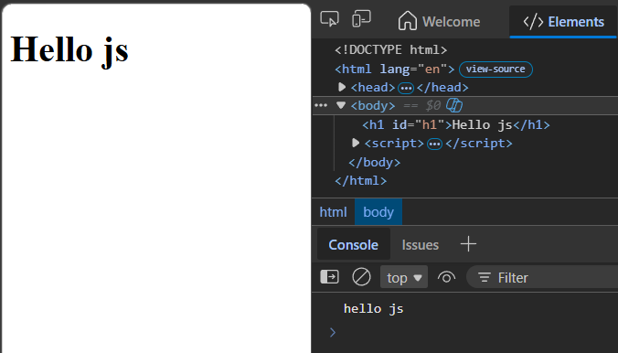
- Log your name and age in console.
CODE:
<!DOCTYPE html>
<html lang="en">
<head>
<meta charset="UTF-8">
<meta name="viewport" content="width=device-width, initial-scale=1.0">
<title>java script</title>
</head>
<body>
<h1 id="h1"></h1>
<script>
console.log("hello js");
document.getElementById('h1').innerHTML="Hello js";
</script>
<h1 id="name"></h1>
<h1 id="age"></h1>
<script>
let name="venkat";
let age=22;
console.log(name);
console.log(age);
document.getElementById('name').innerHTML=name;
document.getElementById('age').innerHTML=age;
</script>
</body>
</html>
OUTPUT:
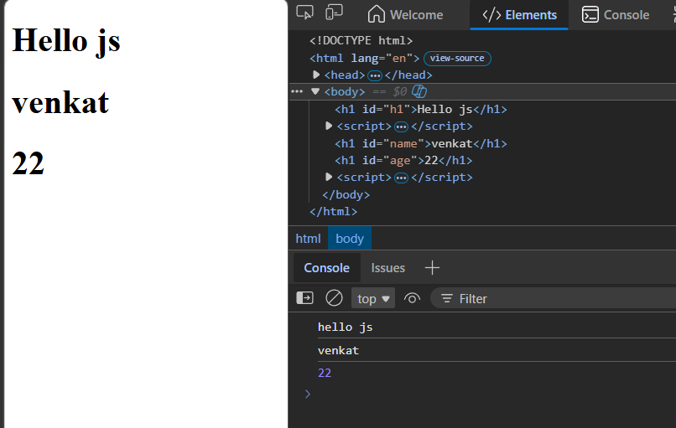

- Write single-line and multi-line comments.
A JavaScript comment is a non-executable annotation in the source code that helps explain the code to human readers.
// This is a single line comment
/*
This is a multi line comment
multiple lines
*/
OUTPUT:
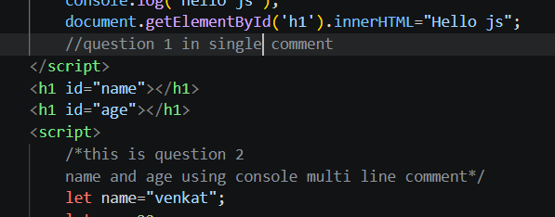
- Integrate HTML with Javascript and display a body with a 'KKR' jersey color and a Box inside it with 'CSK' jersey color and apply the styles with your own creativity.
<!DOCTYPE html>
<html lang="en">
<head>
<meta charset="UTF-8">
<meta name="viewport" content="width=device-width, initial-scale=1.0">
<title>task 15</title>
</head>
<body>
<script>
alert("click the cup");
document.body.style.backgroundColor='blueviolet';
document.body.style.height='100vh';
document.body.style.alignItems='center';
document.body.style.justifyContent='center';
document.body.style.display='flex';
document.body.style.margin='0';
document.body.innerHTML="<div style='width:300px;height:300px;background-color:yellow;border-radius:8%;align-items:center;justify-content:center;display:flex;font-size:500%;box-shadow:5px 5px 5px;'><span style='color:red'>CSK<span><a onclick=alert1()><img src='image.png' width=80px height=80px></a></div>";
function alert1(){
alert("csk win the match");
}
</script>
</body>
</html>
OUTPUT:
